Animal Pharm – Video Notes
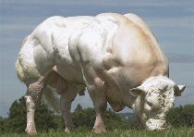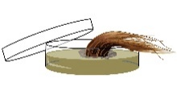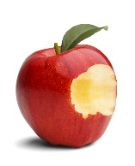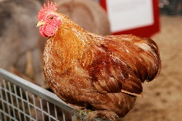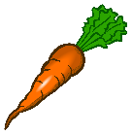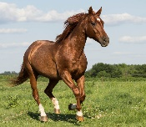

Name:_________________________________ Date:_______________________________________

- Is the biologist, Olivia Judson, for or against GMO’s? _________________________________

- What is the name of the double-muscled bull called? __________________________________

- What is selective breeding? ________________________________________________________

________________________________________________________________________________

- What was the original color of the carrot before the Dutch selectively bred the vegetable as a tribute to their royal family? _______________________________________________________

- Why did Dr. Cahaner breed chickens to be featherless? ________________________________

________________________________________________________________________________

- What does the term transgenics mean? _______________________________________________

_________________________________________________________________________________

- What sea creature did Dr. Houdebine use in rabbits? ____________________________________

- Why do salmon stop growing in the winter? ____________________________________________

___________________________________________________________________________________

- What is the “Enviro-pig?” _____________________________________________________________

___________________________________________________________________________________

- What crop are they genetically modifying to help reduce Vitamin A deficiency? _________

- What does it mean to be a “surrogate” mother in cattle? _____________________________

_____________________________________________________________________________

- Does cloning mean that the animal will look identical to the animal being cloned? ________

_____________________________________________________________________________

- What is the name of “Scampers” clone? ___________________________________________

- Almost all fruit is made by this technique called ____________________________________

- What is the latest prototype of meat that scientists have discovered that is animal free? ___

_____________________________________________________________________________

