“I like to, uh, WELD!”
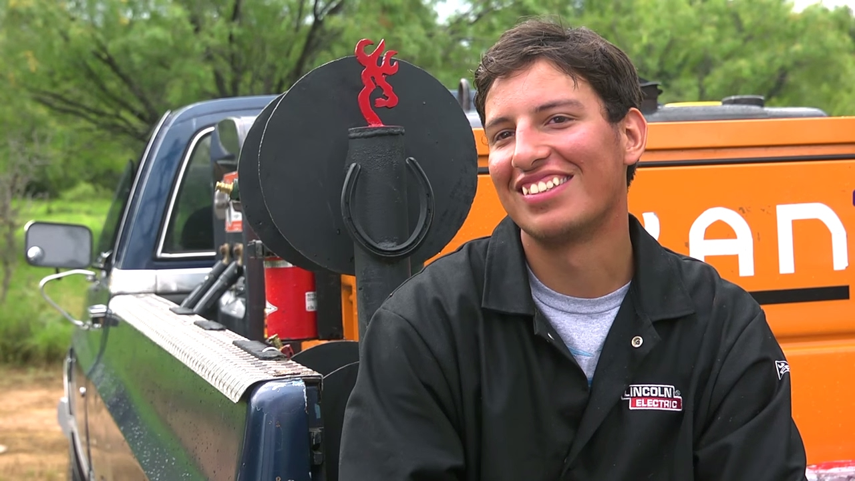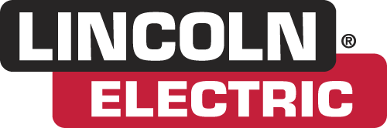
Application Activity
Let’s explore some career possibilities in welding!!!! YAY!
- Please log on to a computer
- Working with a team member, research the websites below and explore information about welding careers
- In 60 minutes, be prepared to answer the following questions:
  - What careers in welding interest you the most?
  - How can welding be high tech?
  - How much money can be made annually in this chosen career field?
  - Where can you get a job in welding and what are the basic requirements?
  - What are some job advancement opportunities available in the welding industry?
America's Job Bank (http://www.ajb.dni.us)
Classifieds Employment (http://www.classifieds2000.com)
Yahoo! Careers (http://careers.yahoo.com/)
MONSTER.COM (http://www.monster.com) (http://nccer.monster.com)
CareerBuilder (http://www.careerbuilder.com)

