**Basic Electricity and Welding**

Name:____________________________ Date:_______________________

**The Arc Welding Circuit**

* The electricity flows from the __________________, through the ________________and across the _____________, through the ________________________ to the work lead and back to the _________________________.

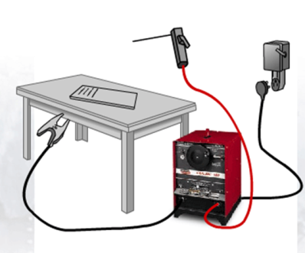

**Basic Electricity**

* ______________– The electrical potential or pressure that causes current to flow
  + *Measured in Volts*
* Current – The movement of charged particles in a specific direction
  + *Measured in Amps*
* Polarity
  + ***DC-*** *(Direct Current   
    Electrode Negative)*
  + ***DC+*** *(Direct Current   
    Electrode Positive)*
  + ***AC*** *(Alternating Current)*

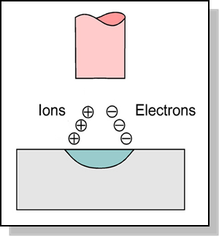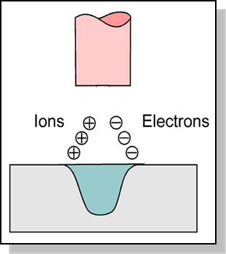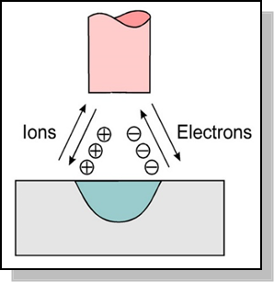

**Metal**

* Most metals can be welded, but ________________________
* The three most common weldable metals include:
  + *_____________________ - inexpensive and strong*
  + *Stainless Steel – does not rust*
  + *Aluminum – does not rust and is light weight*

**Gauge**

* Material thickness is sometimes measured by gauge from 36 (.004 in) to 3 (.2391 in)
  + *For example, steel gauge and measurement in inches:*

16 gauge = .051” 14 gauge = .064” 12 gauge = .081” 10 gauge = .102”

**\*\*\*\*\*PLEASE NOTE: As the gauge number gets smaller … the material thickness gets larger.**

**Types of Joints**

There are ____________ types of welds:

 ___________________

_______________________

 _________________________

 

 