Name:_______________________ Date:_____________________

**Biotechnology Terms**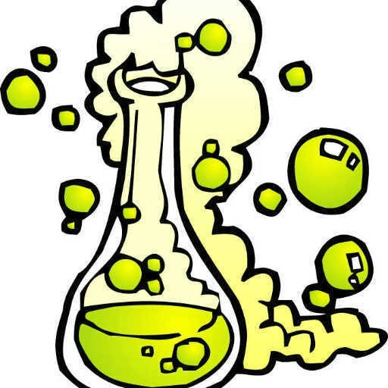

**Directions:** Define the following terms.

Bio:

Improvement by selection:

Selective Breeding:

Genetics:

Heredity:

Gene:

Generation:

Progeny:

DNA:

Nucleic Acid:

Base:

Adenine (A):

Guanine (G):

Cytosine (C):

Thymine (T):

Mapping:

Gene Splicing:

Recombinant DNA Technology:

Gene Mapping:

Clone:

Genetic Engineering:

Ice-minus:

Bovine Somatotropin (BST):

Porcine Somatotropin (PST):

Insulin: