Dodecahedron Project
“FFA Ball”

Name:________________________________ Date:______________________

Directions: You will be creating a dodecahedron, a 12-sided ball with different things we’ve learned about the FFA. Some things you might want to include:

- FFA History (important dates)
- FFA Colors
- Official Dress
- FFA Emblem (parts of the emblem)
- 7 FFA Officer Positions
- “I believe” – The Creed
- What FFA stands for
- The three – component model
- SAE
- Leadership
- Community
- FFA Motto
- FFA Mission
- FFA Memberships
- Anything else you found interesting or important about the FFA
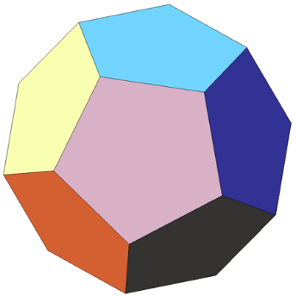

- Be creative, draw pictures, and use color! There are colored pencils, glue sticks, and rulers on the table located in the back of the classroom.

