FFA OFFICIAL DRESS
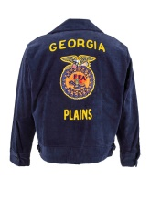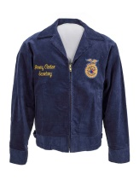

Name:____________________________________ Date:______________________

Why is the FFA jacket so important?

Tradition is a vital part of FFA; the well-known jacket is the _____________________________________________________________________________.

The official colors, which are found on the FFA jacket are National Blue and Corn Cold (national scope of FFA and common interests)

Official Dress for Females:

- _____________________________– skirt is to be at least knee length, hemmed evenly across the bottom, with a slit no longer than 2 inches above the knee, excluding the kick pleat
- White collared blouse & Official ______________ blue scarf
- Black dress shoes with a closed heel and toe (no boots, sandals, open-toed shoes, tennis shoes)
- Black nylon hosiery
- Official FFA jacket zipped to the __________
- Black slacks may be appropriate for traveling and outdoor activities

Official Dress for Males:

- Black dress pants (no jeans – blue or black, leather, pleather, etc.)
- _______________________________ and official FFA tie
- Black dress shoes with a closed heel and toe (no boots, sandals, open-toed shoes, tennis shoes)
- _______________________________
- Official FFA jacket zipped to the top
Awards and Degrees:

- Chapter degree, officer and award medals should be worn ___________________ the name of the right side of the jacket

- _________________________________________ or American Degree key should be worn above the name or attached to a standard key chain

- No more than ___________________________________ should be worn on the jacket. These should represent highest degrees earned, highest office held and the highest award earned.

