FFA Study Guide
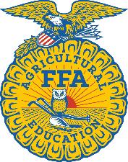

Name:____________________ Date:_____________________

- What are the 7 different officer positions?

- What does each officer position represent (mean)?

- How many FFA officers do we have here at PCHS?

- What year was the FFA established?

- Who wrote the FFA creed?

- What is a CDE?

- Explain what a CDE is.

- How many are available?

- What are the parts of the emblem? What do they mean/represent?

- Who runs the meeting?

- What is the FFA?

- What is the FFA’s mission statement?

- What is the 3 component model for agricultural education?

- What is the FFA motto?

- What are the colors of the FFA?

- When were women allowed to join the FFA?

- Know about New Farmers and when allowed to join FFA

- Know and understand the FFA official dress.

- FFA membership types and the various degrees received in FFA.

- Know opening ceremony parts.

- Know the FFA Creed.

