The Food Pyramid
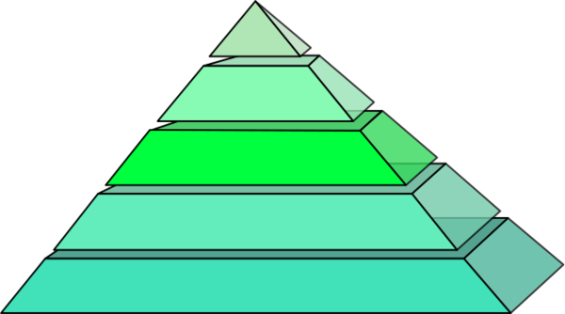

Name:_______________________________ Date:____________________________

Directions: After looking over the newly designed food pyramid and discussing each section, you will be creating your own food pyramid based on the foods that you typically consume daily. Use the Food Pyramid chart to help you setup and organize your own personalized food pyramid. Please include serving size, how active you are, pictures of food items, and how much fluids you drink!

