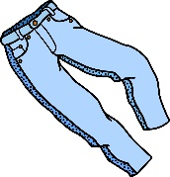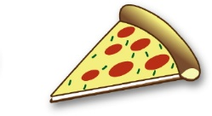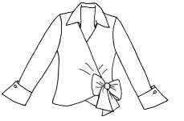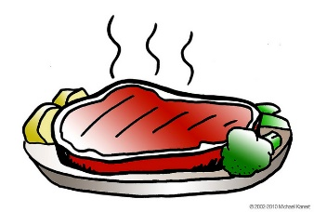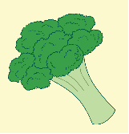

Name:______________________________________ Date:___________________________

**Directions: Answer the following questions:**

1. What are your five (5) favorite foods?
2. What are your five (5) favorite items of clothing?
3. What are the five (5) things that you like most about your home?