Name:____________________________ Date:_______________________________

**Parts of a Weld**

________________ and _______________ welds can be made on many types of joints

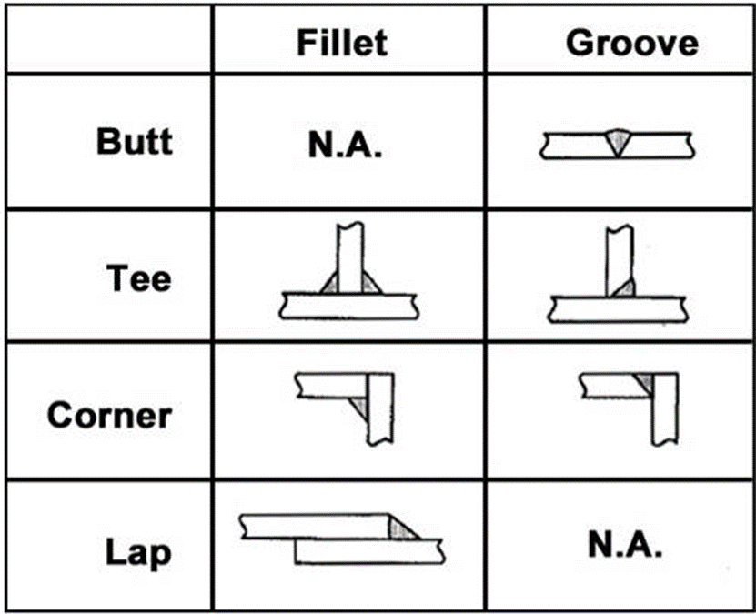

**Fillet Weld Inspection**

* Fillet welds should:
  + *Have a flat to slightly ________________________________*
  + *Be uniform in appearance*
  + *Have equal leg size*
  + *Have good wash-in into base materials*
* This is an example of a good fillet weld:

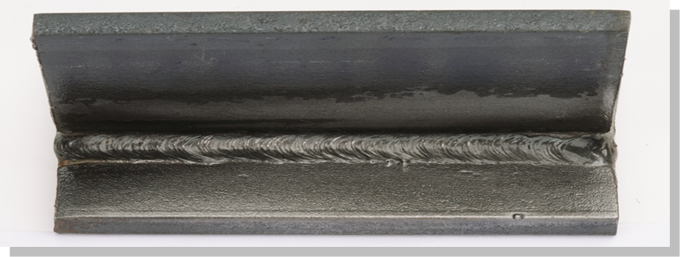

**Welding Symbols**

* Welding symbols give the welder specific instructions about the weld including:
  + *Placement*
  + *Size*
  + *Process*
  + *Any other special notes*
* Welding symbols are
  + *Universally used*
  + *Found on engineering drawings*

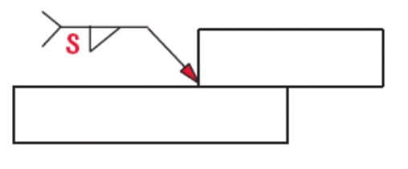

* Welding symbols contain information about the weld to be made
  + *S – leg dimension of the weld*
  + *Triangle – the weld is to be made on the arrow side of this joint*
  + *Tail – any additional information required (i.e. position the weld is to be made)*
  + *Arrow -*

**Welding Positions**

There are various positions that a weld can be made in:

