The Ultimate Guide to Writing a Cover Letter

Name:______________________________ Date:__________________________

What is a cover letter?
____________________________________________________________________________________________________________________________________________

It is meant to:
1.) Introduce yourself to the hiring manager
2.)
3.) Fill in places your resume cannot describe
4.) Further explain other aspects of your resume

Contact Information:
To begin, include both the ________________ and ____________ contact information

Example:

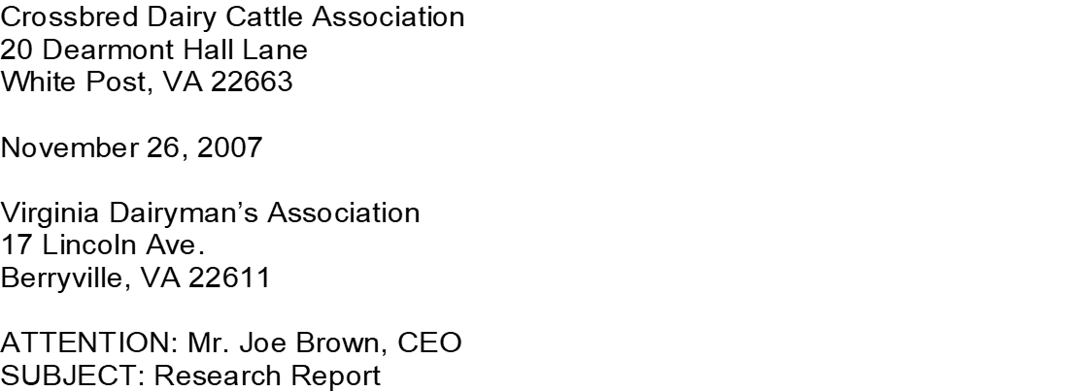

Introduction:
- ________________________________________________________________.

- Put yourself in the hiring manager’s shoes for a second. Would you like to be addressed as “Dear Sir or Madame?” or “To whom it may concern?”

- “Dear Sir or Madame” makes you sound like you’re from the year 1865, and “to whom it may concern” is not very personable.

- You can easily avoid this problem by doing your _________________. Look through the ________________________, LinkedIn, or even give the company a _____________ to ask for the hiring manager’s name.

- Introduce _______________________

- In the first paragraph, begin by telling the employer _______________________
__________________________________________________________________________.
- The rest of this paragraph should briefly present basic info about yourself, including:

- Area of study/expertise

Sell Yourself:
The second paragraph should respond directly to the ____________________ written by the hiring manager.

Describe how your previous job _______________, ___________, and ____________ will allow you to meet the company’s needs.

To make that easier, you should include words and phrases from the job description in your cover letters.

Go The Extra Mile:
Do some ________________ about the company, and try to find out what they are doing and why?

In a third paragraph, explain how you can be an ______________ to the company and help them _____________ any goals in the future.

Conclusion:
Last Paragraph _____________________________

Inform them that you’d love to get _________________________.

Tell them that you’ll be in contact with them in a week if you don’t hear back.

__________________ them for spending the time to read your letter.

