Welding
Toolbox Terms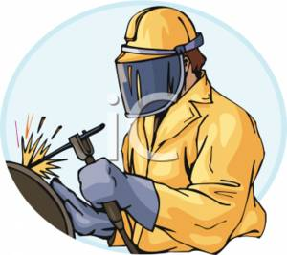
Name:________________________ Date:_____________________

Directions: Define each term.

Arc Welder:

Arc:

Welder:

Electrodes:

Shielded Metal Arc Welding (SMAW)/Arc Welding/Stick Welding:

Slag:

Electrode Holder:

Toolbox Terms
Welding - 2

Name:_______________________ Date:_____________________

Ground Clamp:

Chipping Hammer:

National Electrical Manufacturers Association (NEMA):

End Marking:

Spot Marking:

Group Markings:

American Welding Society (AWS):

Tensile Strength:

Carbon Arc Torch:

